How to Add or Update a DNS Record in a Route 53 Hosted Zone
Oct 23, 2026 · @Kunal Shrivastava
Every DNS record change goes through Git and a reviewed change set. Developers: use Section 1. New to Git or the pipeline: read Section 2, which explains each step with screenshots.

Section 1 — Quick steps (developers)
Add or edit one AWS::Route53::RecordSet resource in the zone's template on a branch, get the PR approved by two people and merged, run the pipeline from main with Deploy = no, check and execute the change set, verify with dig, and close the CR.
Record details (fill per request)
Item | Value
Zone | <zone-name> (public or private), zone ID <zone-id>
Account (OU) | <zone-account-name> (Production). Test and PPE domain zones live here too.
Stack | <zone-stack-name> (one stack per zone)
Template | production/<zone-account-folder>/<zone-stack-name>.yaml
Record | <name> · <type> · TTL <ttl> · value <value>
Action | Add a new record, or update an existing one
Pipeline | <cfn-deploy-workflow> (drift check and change set), run from main
Pipeline parameters | template = the Template path above · Deploy = no
Expected pipeline result | Green run; drift check IN_SYNC; change set created and named in the log; nothing executed
Expected change set | Add: 1 row Add · AWS::Route53::RecordSet. Update: 1 row Modify · Replacement False
Verify | dig @<zone-name-server> <name> <type> +short returns the new value
Snippets
# Standard record (A, CNAME, TXT, MX ...): one resource per record
RecordAppCname: # unique logical ID; never rename it later
Type: AWS::Route53::RecordSet
Properties:
HostedZoneId: !Ref HostedZone # the zone resource in this stack
Name: app.<zone-name>
Type: CNAME
TTL: '300'
ResourceRecords:
- target.example.net

# Alias to a CloudFront distribution
RecordWwwAlias:
Type: AWS::Route53::RecordSet
Properties:
HostedZoneId: !Ref HostedZone
Name: www.<zone-name>
Type: A
AliasTarget:
DNSName: <distribution-id>.cloudfront.net
HostedZoneId: Z2FDTNDATAQYW2 # fixed value for every CloudFront alias
EvaluateTargetHealth: false
Updating? Change TTL, ResourceRecords or AliasTarget only. Changing Name or the logical ID replaces the record.
Steps (numbers match Section 2, which explains each one with screenshots)
Step | Do this
1 | Open the zone's template. Record in the template → update it. Not in the template but live in Route 53 → stop (see Troubleshooting).
2 | Repo → Branches → New branch: <type>/<JIRA-ID>-dns-<record-name> from main.
3 | Open your branch → the zone template → pencil icon → add or edit the AWS::Route53::RecordSet resource → Commit changes to your branch.
4 | PR to main titled <CHG-number> <zone-account-name> <record-name>: <change> → two approvals → Merge pull request → delete the branch.
5 | Actions → <cfn-deploy-workflow> → Run workflow from main: template = Template path, Deploy = no. Drift check must show IN_SYNC.
6 | CloudFormation (<zone-account-name>, <region>) → zone stack → Change sets → open it. Only the expected row, nothing else.
7 | Execute change set → wait for UPDATE_COMPLETE → run the Verify check.
8 | Add the PR link, run link, change set name and dig output to the CR in ServiceNow, then close it.
You need: GitHub write access, SSO <permission-set> on <zone-account-name>, and an approved <CHG-number> (the zones live in production). Problems: see Troubleshooting at the end of Section 2.

Section 2 — Reference guide (non-developers)
How to find the zone's code, create a branch, commit, raise a PR, run the pipeline and review the change set and close the CR, with screenshots.

How to implement a DNS change: end to end
Each record is one AWS::Route53::RecordSet resource in the zone's CloudFormation template. You change the template in GitHub, two people approve the PR, the pipeline creates a change set, and you review and execute it in the console. Nothing changes in DNS until you click Execute change set.
Follow these stages in order; each links to the step that explains it, with screenshots.
- Is there a stack for this zone, or do I need a new one? Each zone has one stack, named in the hosted zone's aws:cloudformation:stack-name tag. Your record goes into that stack's template; a record never needs a new stack (Step 1).
  - Zone has no stack → stop. It must be imported first; contact <owner>.
  - Record is live in Route 53 but not in the template → stop. It was created by hand; contact <owner>.
- Where is its code in Git? Copy the zone stack's Description and search for it in GitHub. Zone templates sit under production/<zone-account-folder>/ (Where the zone's code lives, Step 1).
- Make the change. Create a branch, add or edit the record in the zone template with the pencil icon, and commit (Step 2, Step 3).
- Get it approved and merged. Raise a PR to main, and merge it after two approvals (Step 4).
- Which pipeline do I run after the merge? <cfn-deploy-workflow>: Actions → Run workflow from main, with the zone template path and Deploy = no (Which pipeline to run, Step 5).
- What should I see while it runs? First the drift check: IN_SYNC → carry on; DRIFTED → stop. Then the change set name is printed and the pipeline stops (Step 5).
- Review and execute the change set. It must show only your record; then click Execute change set (Step 6, Step 7).
- Verify in AWS. The stack reaches UPDATE_COMPLETE, and dig returns the new value (Step 7).
- Close the CR. Add the evidence to the CR in ServiceNow, then close it (Step 8).
Example used below: add CNAME app.<zone-name> → target.example.net, TTL 300.

Before you start
- ☐ Write access to GitHub repo plat-eng/AWS-Landing-Zone
- ☐ AWS SSO access to <zone-account-name> with <permission-set>
- ☐ Approved change record <CHG-number> (the zones live in the production account)
- ☐ The request: record name, type, value, TTL, and whether it replaces an existing record

Rules
- Never add, edit or delete records in the Route 53 console. Console edits cause drift or block the next change.
- One request = one branch = one PR = one change set. Name branches and PRs by the IMS rules (Steps 2 and 4); delete your branch once merged, and close PRs you abandon.
- Every PR needs two approvals. Run the pipeline from main straight after the merge.
- Never change the AWS::Route53::HostedZone resource here. Replacing a zone breaks NS delegation and VPC associations.
- Never rename a record's logical ID or change its Name; both replace the record.
- Stop if the change set shows Remove, Replacement = True, or rows you didn't change.

Where the zone's code lives
The zones are in the production account, so their templates sit under production/ in the repo.
[Screenshot S1] Your OU diagram, with the production account that holds the zones highlighted.
<repo>/
└── production/
└── <zone-account-folder>/
├── <zone-stack-name>.yaml ← HostedZone + one RecordSet per record
└── <another-zone-stack>.yaml
[Screenshot S2] GitHub: production/<zone-account-folder>/ expanded to show the zone templates.
↑ Back to the end-to-end summary

Which pipeline to run
DNS record changes always use one pipeline: the drift check and change set pipeline.
Pipeline: <cfn-deploy-workflow>. Run it from Actions on main, after the PR is merged.
Parameters: template = the zone template path · Deploy = no
Expected result: a green run. The log shows the drift check IN_SYNC and the new change set's name; nothing is executed until you execute the change set in the console (Step 6).
Not for DNS: <direct-deploy-workflow> (stacks with JSON settings, e.g. Firewall Manager policies) and <truststore-workflow> (trust store certificates).
↑ Back to the end-to-end summary

Step 1 — Find the template and check the record
- Route 53 console (<zone-account-name>) → Hosted zones → open <zone-name> → note the Hosted zone ID.
- Filter the records by the record name. Note whether it exists and its current value.
- Find the zone's stack: hosted zone Tags → aws:cloudformation:stack-name. No tag? Run this in CloudShell:
aws cloudformation describe-stack-resources \
--physical-resource-id <zone-id> --region <region> \
--query 'StackResources[0].StackName' --output text
- CloudFormation → that stack → Stack info → copy Description → search GitHub for repo:plat-eng/AWS-Landing-Zone "<description>" → open the template.
- Search the template for the record name:
What you find | Do
Record is in the template | Update: edit that resource (Step 3)
Record is nowhere (not in Route 53, not in the template) | Add: new resource (Step 3)
Record is in Route 53 but not in the template | Stop. It was created by hand; ask <owner> to import it first.
Example: app.<zone-name> is in neither place → add it.
[Screenshot S3] Route 53 › Hosted zones › <zone-name>. Highlight: Hosted zone ID and the records filter box.
[Screenshot S4] CloudShell with the command and the stack name it returns.
↑ Back to the end-to-end summary

Step 2 — Create a branch
- Open plat-eng/AWS-Landing-Zone.
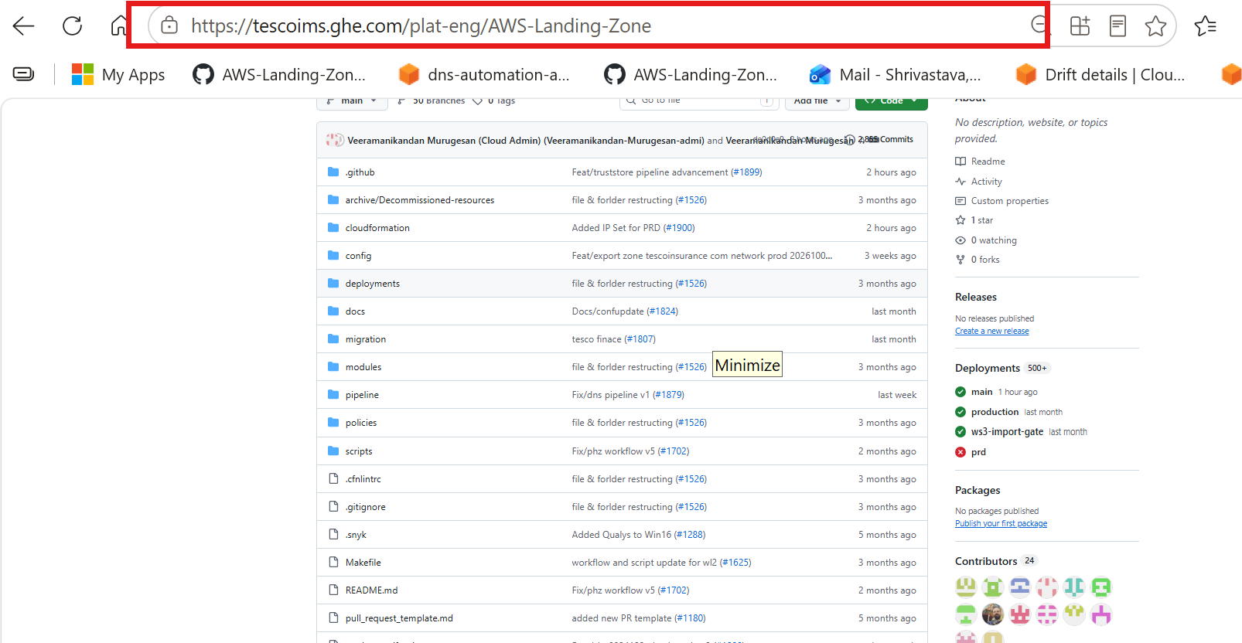
- Click Branches, next to the branch selector.
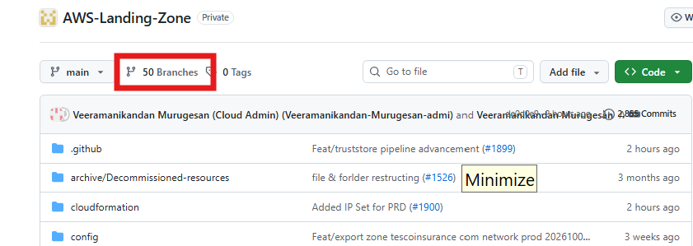
- Click New branch (top right).
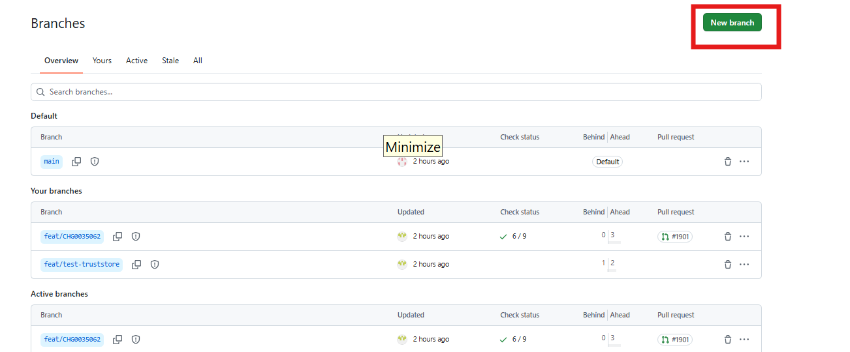
- Type the branch name <type>/<JIRA-ID>-dns-<record-name>, keep Source = main, then click Create new branch.
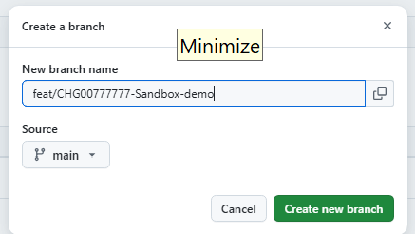
- The branch appears under Your branches. Click its name.
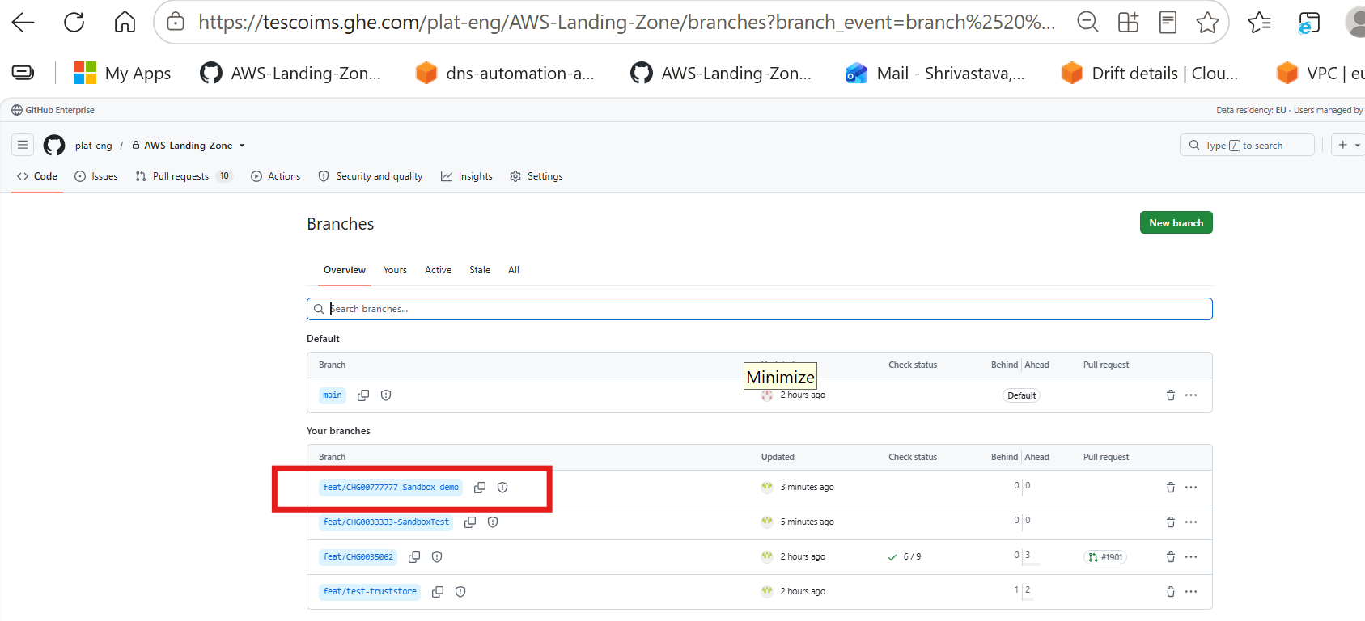
- Check the address bar ends in /tree/<branch-name>. You're now on your branch.
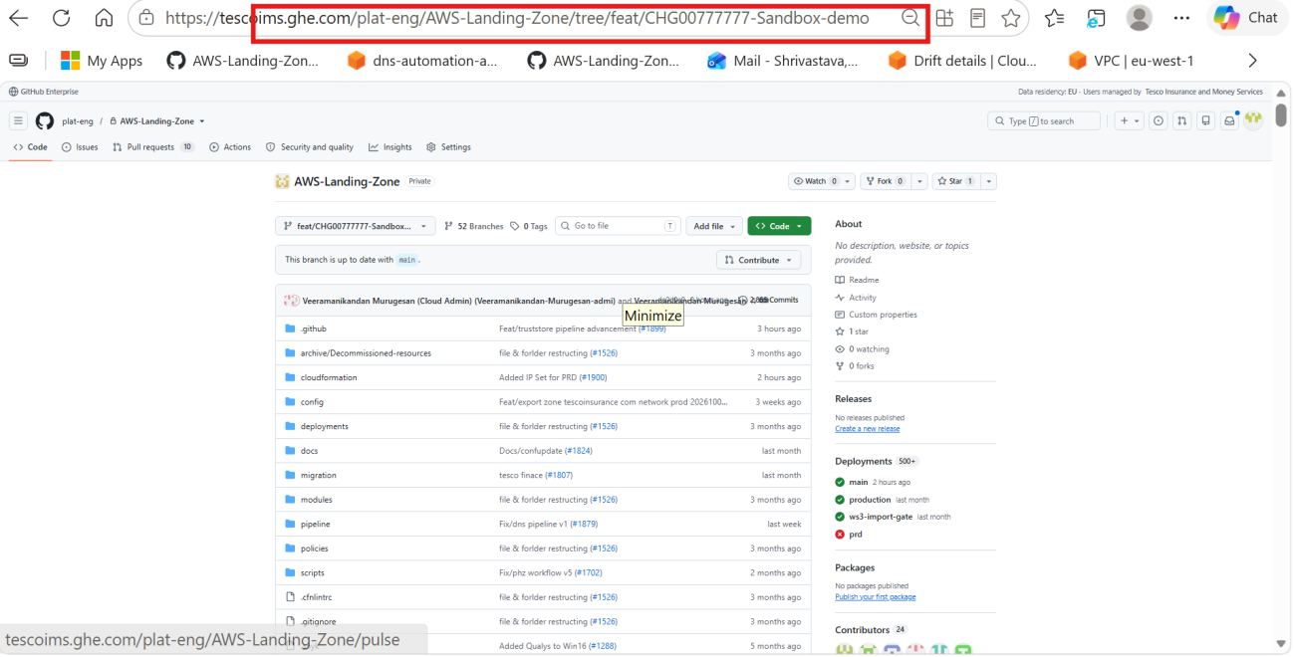
Branch name (IMS rule): <type>/<JIRA-ID>-<short-description>, lowercase, with hyphens between words. Types: feat/ new features · fix/ bug fixes · chore/ maintenance and IaC changes · docs/ documentation only · hotfix/ urgent production fixes. The screenshots show a sandbox demo branch; yours gets its own name.
↑ Back to the end-to-end summary

Step 3 — Edit the zone template and commit
- On your branch (the branch selector shows its name, not main), open production/<zone-account-folder>/<zone-stack-name>.yaml.
- Click the pencil icon (Edit this file). Under Resources:, add a new record resource or edit the existing one. Use the snippets in Section 1.
- Commit changes… → message <ticket>: add CNAME app.<zone-name> → keep Commit directly to the <your-branch> branch → Commit changes.
Example:
Resources:
HostedZone:
Type: AWS::Route53::HostedZone
...
+ RecordAppCname:
+ Type: AWS::Route53::RecordSet
+ Properties:
+ HostedZoneId: !Ref HostedZone
+ Name: app.<zone-name>
+ Type: CNAME
+ TTL: '300'
+ ResourceRecords:
+ - target.example.net
YAML is indent-sensitive: line the new resource up with the others, 2 spaces under Resources:. CloudFront aliases work in public zones only.
[Screenshot S6] The zone template on your branch. Highlight: the branch selector and the pencil icon.
[Screenshot S7] Editor with the new resource. Highlight: the added lines.
[Screenshot S8] Commit changes dialog. Highlight: message and "Commit directly to the … branch". Reusable.
↑ Back to the end-to-end summary

Step 4 — Raise a PR and merge
Two people must approve the PR before it's merged.
- Pull requests → New pull request: base main ← compare your branch. Files changed must show only your record.
- Title, per the IMS rule: change number, account, record, then the change, e.g. <CHG-number> <zone-account-name> app.<zone-name>: add CNAME. Add two reviewers (<reviewer-or-team>) → Create pull request.
- After two approvals: Merge pull request → Confirm merge → Delete branch.
[Screenshot S9] New pull request. Highlight: base ← compare and Files changed. Reusable.
[Screenshot S10] Pull request with two approvals and the Merge pull request button. Reusable.
↑ Back to the end-to-end summary

Step 5 — Run the pipeline
- Straight after the merge: Actions tab → <cfn-deploy-workflow> → Run workflow.
- Use workflow from: main. Template: production/<zone-account-folder>/<zone-stack-name>.yaml. Deploy: no.
- Run workflow → open the run → wait for the green tick.
- In the log, check drift = IN_SYNC and note the change set name.
Drift shows DRIFTED → stop. Someone changed records in the console; contact <owner>.
[Screenshot S11] Run workflow panel filled in. Highlight: main, template path, Deploy = no.
[Screenshot S12] Finished run log. Highlight: drift result and change set name.
↑ Back to the end-to-end summary

Step 6 — Review the change set
- AWS console (<zone-account-name>, <region>) → CloudFormation → Stacks → zone stack → Change sets → open the one named in the log.
- Check every row:
You did | Expect | Stop if
Add a record | 1 row: Add · AWS::Route53::RecordSet | Any other row
Update a record | 1 row: Modify · Replacement False | Replacement True (record deleted and recreated)
Either | — | Any row on AWS::Route53::HostedZone
[Screenshot S13] Change set › Changes. Highlight: Action = Add, type = AWS::Route53::RecordSet.
Not as expected → Delete the change set, fix it through a new PR (Steps 2–4), then rerun Step 5.
↑ Back to the end-to-end summary

Step 7 — Execute and verify
- Execute change set → keep Roll back all stack resources → Execute change set.
- Events tab → wait for UPDATE_COMPLETE.
- Check the answer from the zone's own name server (no cache). Name servers are on the hosted zone page.
dig @<ns-xxxx.awsdns-xx.com> app.<zone-name> CNAME +short
# expected: target.example.net.
Private zone: run dig app.<zone-name> (no @) from an instance in an associated VPC. Updates: resolvers that cached the old value keep it until its TTL runs out.
[Screenshot S14] Execute change set dialog. Reusable.
[Screenshot S15] Stack › Events. Highlight: UPDATE_COMPLETE.
[Screenshot S16] Route 53 › <zone-name> › records with the new record. Highlight: name, type, value.
↑ Back to the end-to-end summary

Step 8 — Close the CR
Close the CR only after the stack reaches UPDATE_COMPLETE and dig returns the new value.
- Open the CR <CHG-number> in ServiceNow.
- In Work notes, add the merged PR link, the pipeline run link, the drift result and change set name, the final stack status, and the dig output. Evidence missing? Say so in the notes; don't leave it out.
- Set Close code to match what happened (Successful only if every check passed) and write Close notes.
- Move the CR to <cr-close-state>, as your change process requires.
Example close notes: Added CNAME app.<zone-name> → target.example.net (TTL 300) in stack <zone-stack-name>, <zone-account-name>. Change set executed; stack UPDATE_COMPLETE; dig returns the new value.
[Screenshot S17] ServiceNow CR with work notes and close details filled in. Highlight: State, Close code, Close notes. Reusable across runbooks.
↑ Back to the end-to-end summary

Troubleshooting
Find the symptom, apply the fix, then rerun from the step shown.
Symptom | Likely cause | Fix
Execution fails: record "already exists" | The record was created in the console, outside the stack | Stop. Ask <owner> to import it into the stack, then redo the change as an update.
Change set shows Replacement = True | Name or the logical ID changed | Restore the original Name and logical ID through a new PR; rerun Step 5.
Change set shows rows you didn't touch | Another merged change to the zone template hasn't been deployed yet | Don't execute. Check the file's history on main with <owner>.
Drift check DRIFTED | Records edited in the console | Stop. <owner> reconciles first; CloudTrail ChangeResourceRecordSets events (us-east-1) show who changed what.
dig still returns the old value | Resolver cache holds it until the old TTL expires | Query the zone's name server with @ns-…; wait out the TTL.
Merge pull request is disabled (merging is blocked) | Fewer than two approvals, or checks still running | Wait for both approvals and green checks.
Pipeline fails at the AWS credentials step | Deploy role doesn't trust the repo, or is missing in the account | Contact <owner>.
Can't see the stack or change set | Wrong account or region | Check the account and region (top right).

References
- Route 53 template snippets, including the CloudFront alias zone ID — AWS CloudFormation
- View a change set — AWS CloudFormation
- describe-stack-resources — AWS CLI

Review notes (delete before publishing)
Confirm these, fill the placeholders, then capture S3, S4 and S6–S17 during one low-risk change, such as a TXT record in a test zone. S8, S9, S10 and S14 can be reused across runbooks; the Step 2 branch screenshots are already in place.
- ☐ Stacks: IMS zones sit in the ims-network-route53-* stacks (being split into public and private); imported zones such as tescoforbusiness.com have one stack each. Fill the Template path per zone.
- ☐ Region the zone stacks are deployed in.
- ☐ Logical IDs: the zone resource name (HostedZone?) and a record naming convention (draft: Record<Name><Type>).
- ☐ Test and PPE zones: do they all live in the production account?
- ☐ Change record: needed for every DNS change, including test and PPE zones?
- ☐ Console-created records: who imports them into the stack, and how.
- ☐ Repo paths: the repo root in the Step 2 screenshots has no top-level production/ folder. Confirm the full path to the zone templates, then update the folder tree and Template path.
- ☐ Branch screenshot: it shows feat/CHG00777777-Sandbox-demo, but the IMS rule asks for a Jira ID and lowercase. Keep it, or retake it with a compliant name.
- ☐ CR closure: who closes the CR, and which states it moves through (fill <cr-close-state>).
Placeholders: <zone-account-name>, <zone-account-folder>, <region>, <permission-set>, <cfn-deploy-workflow>, <owner>, <reviewer-or-team>.

